Map & Directions
From San Diego  - East on Interstate 8  - Exit Fourth Street - North  - Right on 6th Street  - Continue past the railroad tracks  - Our school will be on your  left-hand side  From Yuma  - West on Interstate 8  - Exit Fourth Street - North  - Right on 6th Street  - Continue past the railroad tracks  - Our school will be on your  left-hand side | 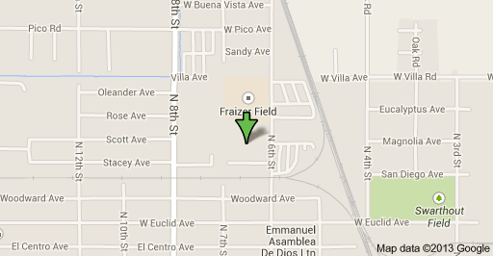
From Los Angeles / Riverside
- East on Interstate 10  - Exit Highway 86 - South  - Enter City of Westmorland  - Right on Forrester Road  - Continue South on Forrester Road  (approx. 15 miles) | - Take Interstate 8 - East  - Exit Fourth Street - North  - Right on 6th Street  - Continue past the railroad tracks  - Our school will be on your  left-hand side

